1. Introduction
1.1 Purpose: The purpose of this document is to give a detailed description of the requirements for the “Smoke&Drink.com” web application. It will illustrate the purpose and complete declaration for the development of system. It will also explain system constraints, interface and interactions with other external applications. This document is primarily intended to be proposed to a customer for its approval and a reference for developing the first version of the system for the development team.
1.2 Scope: There are some products which aren’t available for all peoples. There are certain products which aren’t legal for some people from some other nationalities. Again there are some products which aren’t legal for the people of all ages. For example, if we think about alcohol we see this is not legal in all country. There are some religious and social restrictions for some people. Again if alcohol is legal for a certain group of people, problem arises with the age. Online marketplaces can’t verify the ages and nationality. So these products are very tough to sell in online marketplace.

Our “Smoke&Drink.com” web-application will come up with the following solution:
a. This website will allow customers an access to a wide range of products which are usually not accessible.

b. Buying products using this website will reduce consumers’ time and cost.

c. Finally, consumers will have to provide with their National ID, Passport or any other identity documentation which gives both consumers and sellers legal rights.

1.3 Definitions

Term | Definition
Customer | Person who will be able to sign up and login and order products.
Admin | Panel consists of members who will monitor the website, buying and selling processes, etc.
Database | Collection of all the information monitored by this system.
Use Case | Overview of the system.
System | Processes through which the admin panel and customers are connected to the website.
1.4 Reference

2. Overall Description:
This section will give an overview of the whole system. The system will be explained in its context to show how the system interacts with other systems and introduce the basic functionality of it. It will also describe what type of stakeholders that will use the system and what functionality is available for each type. At last, the constraints and assumptions for the system will be presented.
2.1 System Environment:
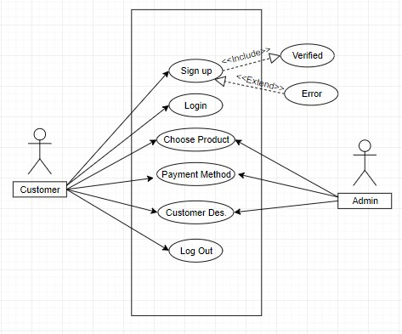
Figure – 1: Use Case Diagram
The Smoke&Drink.com web application has two active actors. The Customer will have six major options to interact with those. To use this system one customer has to open an account first, then by logging in, she/he will be able to use our system.

2.2 Functional Requirements Specification
This section outlines the use cases for each customers separately.
2.2.1 Customer Use Case
Use Case: Sign Up
Brief Description: User will give his name, email address and password to sign up initially. After completing this step user will be asked to scan his/her NID/Password or any other valid document to buy some restricted products. Upon successful signing up user will be asked to be logged in.
Diagram:
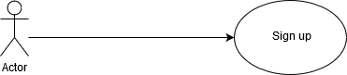

Use Case: Login
Brief Description: when User is already create an account. Then User can move to the Login option. User give the User name and password according to the information as he/she give sign up option. If he/she is verified then he/she can access to the next function. If he/she is not verified then he/she will get an error message.
Diagram:
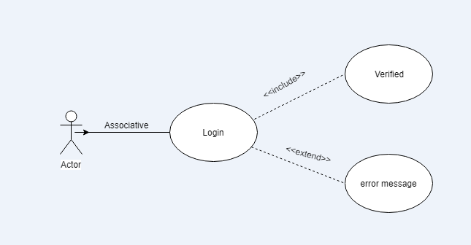

Use Case: Chose Product
Brief Description: After the verification, User can access to the Chose product function. In this section User can order their suitable product as he/she like. In this section User can also set their quantities as he/she wants.
Diagram:
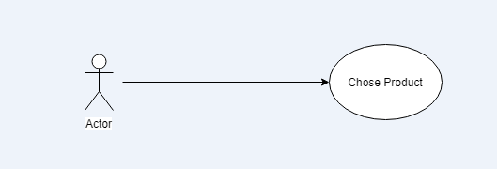

User Case: Payment Method
Brief Description: After choosing quantitative product, User now enter into the payment method. Any user has the option to pay in two ways. They are:
- Cash on Delivery
- Pay Instantaneously (which is through using Credit Card)
Diagram:
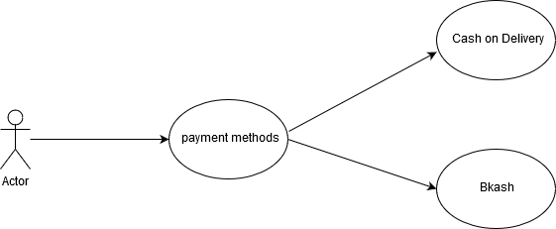

User Case: Logout
Brief Description: After fulfill all the criteria User can log out for his/her better security.
Diagram:

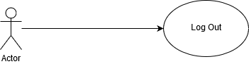

2.2.2 Admin use case
Use case: Choose product
Brief Description: In this term admin can handle the situation of customer wants. Admin can also update this product for betterment. Admin can also control the price of product.
Diagram:
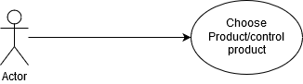

Use case: Payment Method
Brief Description: Admin get the order from the customer. And he offer to pay the bill in Bkash (Or Visa, Mastercard, Rocket, NexusPay etc) or Cash on delivery (COD).
Diagram:
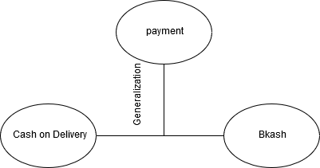

Use case: Customer Description
Brief Description: After confirm the product from customer, then admin give him/her to write the information like Name, Address, Phone Number.
Diagram:

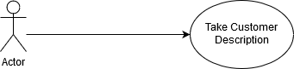

2.3 User Characteristics
The Customer/ Buyer is expected to Internet literate and be able to use internet. For some products customer has to be aged 18 or plus and expected to have a valid document so that the sellers verify the age and nationality of the customer.
2.4 Non-Functional Dependencies
The Smoke&Drink.com will be on a server with high speed Internet capability. The web application developed here assumes there will be a connection between the user interface and an working Database. The speed of the customers’ and admins’ connection will depend on the hardware used rather than characteristics of this system. The system won’t ensure how actors will interact with the system to get access to the system.

3.0. Requirements Specification
3.1 External User Requirements
The communication between the different parts of the system is important since they depend on each other. However, in what way the communication is achieved is not important for the system and is therefore handled by the underlying operating systems for the web portal.

3.2 Functional Requirements:
The logical Structure of data is contained in section 2.2.1
3.2.1 Sign up
Use Case Name | Sign up
XRef | Section 2.2.1 , Sign up
Trigger | The Reader assesses the online web application
precondition | The web is displayed the sign up form
Basic Path | - At first User have to fill up the sign up form if he doesn’t create before.  - Then the User’s information will save into the admin server.  - And then he can access to the next function called “choose product”.
Post condition | The customer information will save into the admin server.
Exception paths | If the information is not correct then admin will sent a message to try again.

3.2.2 Login
Use Case Name | Login
XRef | Section 2.2.1 , Login
Trigger | The User selects the login option
Precondition | The web is displayed the login form, and then get access to the next function.
Basic path | - User have to give the UserID and Password for access to the web application.  - Admin will match the UserID and Password, then get free to access.
Post condition | Get free access to buy products.
Exception paths | Sent a error message to the user.

3.2.3 Choose Product
User Case Name | Choose Product
XRef | Section 2.2.1, Choose Product
Trigger | Many product is shown to the User from the admin server.
Precondition | The User can access to order the product.
Basic Path | - User can choose his/her suitable product and order that which will store in cart.  - There will be mentioned the quantities of the products.  - That ordering product will be save in the admin server.
Post condition | The User’s ordering product will be store in server.
Exception Paths | The User will be abandon the operation at any time due to insufficient of product.

3.2.4 Payment Methods
Use Case Name | Payment Methods
XRef | Section2.2.1, Payment Methods
Trigger | There will be two option to pay the bill.
Precondition | The User have to pay the bill in two ways.
Basic Path | - User have to pay the bill either in ‘Cash on Delivery’ or in ‘Bkash’.
Post condition | The bill will be stored in server
Exception paths | If not to pay the bill the order will be cancelled.

3.2.5 Customer Description
User Case Name | Customer Description
XRef | Section 2.2.1, Customer description
Trigger | User have to input the information about him/her.
Precondition | The customer will get a form called “Customer Information”.
Basic Path | - In this section Customer have to fill the information like Name, Address, Mobile Number.  - The information will save into the admin server.
Post condition | Information will be updated into the server.
Exception | The User will be abandon the operation at any time.

3.2.6 Log Out
User Case Name | Log Out
XRef | Section 2.2.1, LogOut
Trigger | User exit from the Web application.
Precondition | After finishing order User can exit.
Basic path | - User can exit from the web application.
Post condition | Web application will be secured for User.
Exception | The User will be abandon the operation at any time.

  - Non Functional Requirements
3.3.1 Security
- The system use SSL (secured socket layer) in all transactions that include any confidential customer information.
- The system must automatically log out all customers after a period of inactivity.
- The system should not leave any cookies on the customer’s computer containing the user’s password.
- The system’s back-end servers shall only be accessible to authenticated administrators.
- Sensitive data will be encrypted before being sent over insecure connections like the internet.

    - Reliability
- The system provides storage of all databases on redundant computers with automatic switchover.
- The reliability of the overall program depends on the reliability of the separate components. The main pillar of reliability of the system is the backup of the database which is continuously maintained and updated to reflect the most recent changes.
- Thus the overall stability of the system depends on the stability of container and its underlying operating system.

    - Availability

The system should be available at all times, meaning the user can access it using a web browser, only restricted by the down time of the server on which the system runs. In case of a of a hardware failure or database corruption, a replacement page will be shown. Also in case of a hardware failure or database corruption, backups of the database should be retrieved from the server and saved by the administrator. Then the service will be restarted. It means 24 X 7 availability.

    - Maintainability

A commercial database is used for maintaining the database and the application server takes care of the site. In case of a failure, a re-initialization of the program will be done. Also the software design is being done with modularity in mind so that maintainability can be done efficiently.

    - Portability

The application is HTML and scripting language based. So The end-user part is fully portable and any system using any web browser should be able to use the features of the system, including any hardware platform that is available or will be available in the future.
An end-user is use this system on any OS; either it is Windows or Linux.
The system shall run on PC, Laptops, Smartphone (Android, IOS etc.)etc.

3.4 Logical Structure

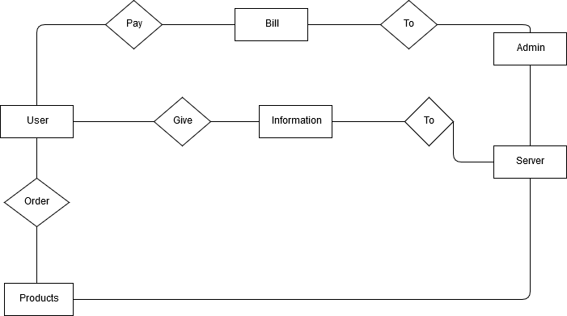
Figure: Logical Structure Diagram of our System

4. Interface Requirement
Various interfaces for the product could be-
1. Login Page
2. Registration Form
3. There will be a screen displaying information about product that the shop having.
4. If the customers select the buy button then another screen of shopping cart will be opened.
5. After all transaction the system makes the selling report as portable document file (.pdf) and sent to the customer E-mail address.

4.1 GUI

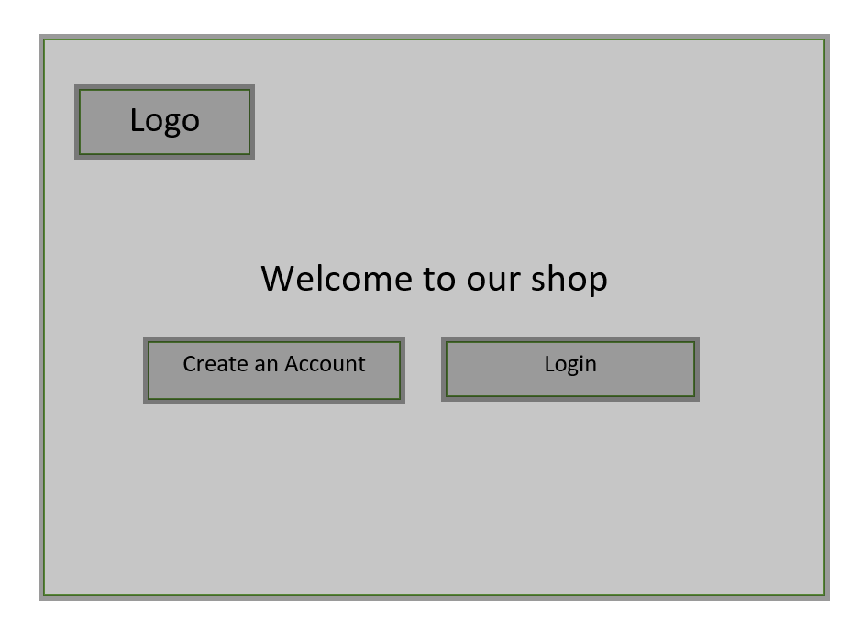
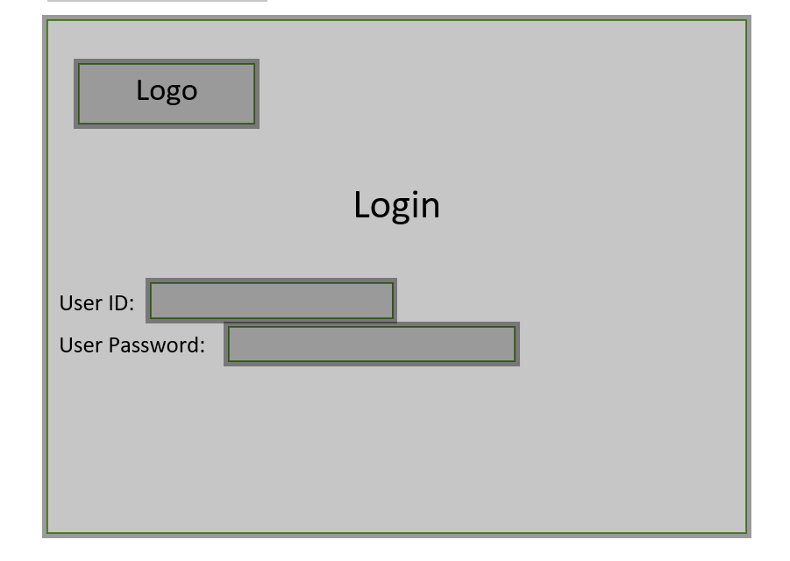
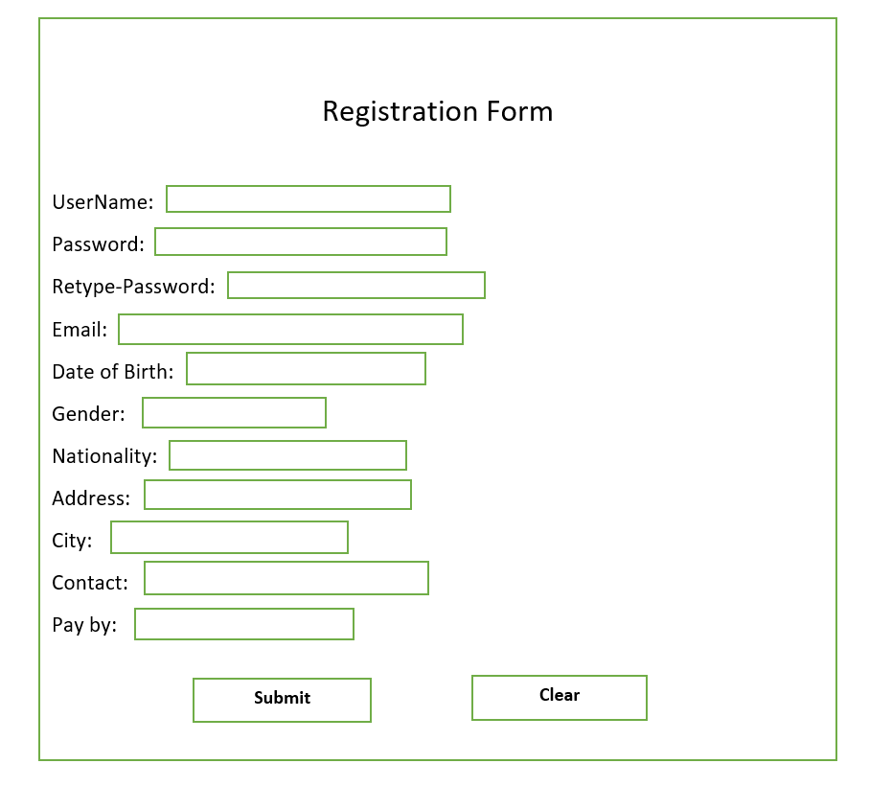

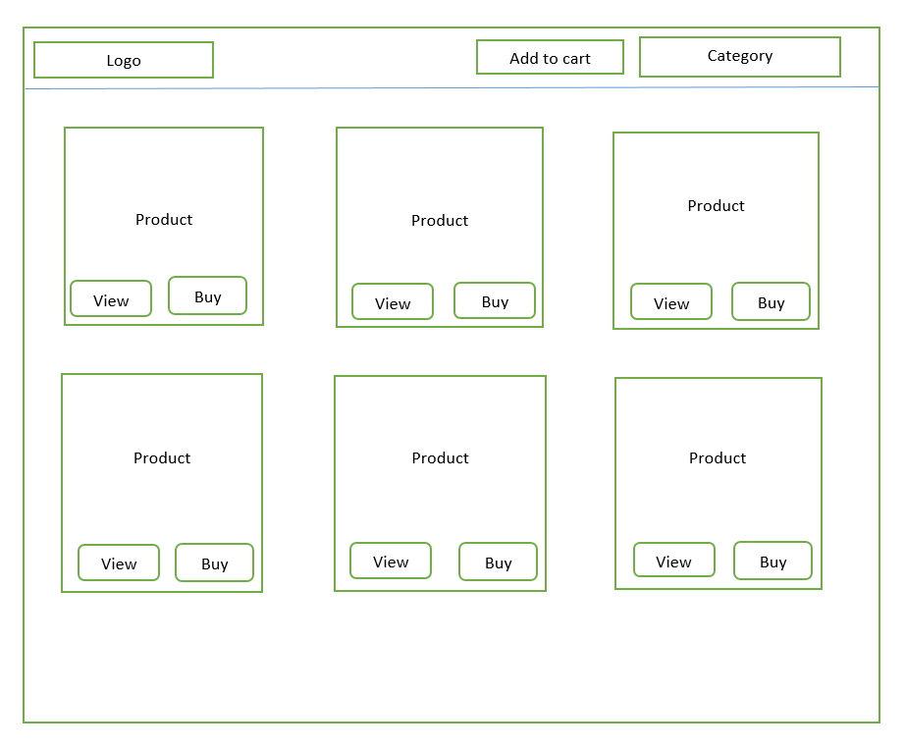

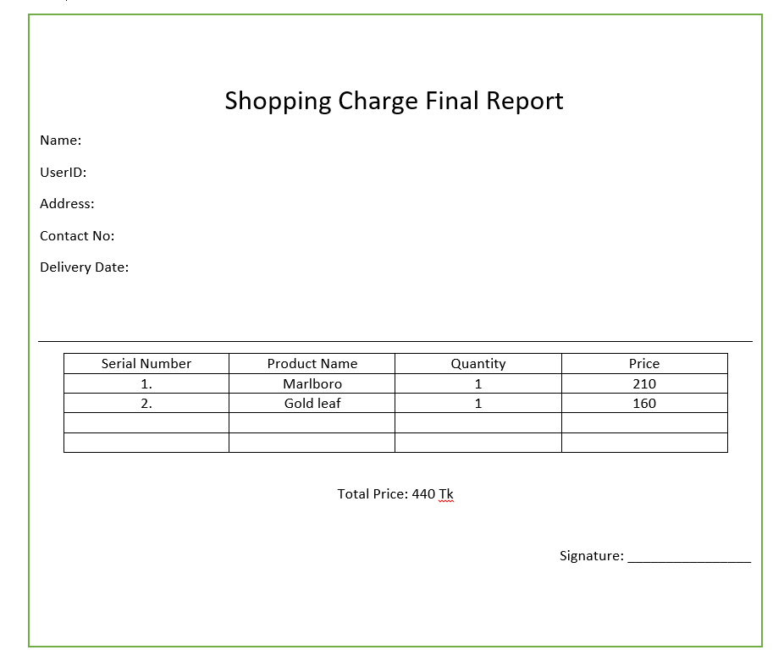

5 Prioritizing

There’ll be several options we have planned. Features, Artificial-Intelligence implementation are so tough to implement within a shortest period of time. We will first try to use Machine Learning method to train our system. If it wouldn’t be possible for some reason we will move to some machine learning framework of Python, like OCR to implement our Artificial-Intelligence (AI) feature to our system. Our first focus will be on building a user-friendly UI, having a working database system, a strong security system for protecting user data and privacy. However though we will try to build a strong data backup system but we may omit this option if we couldn’t make it within this time.

